CRUD Nodejs y Mongodb
Fazt Code

https://www.youtube.com/watch?v=3J925fRl_UE

Resumo do vídeo feito por Roberto Pinheiro

Criando arquivo de dependências

npm init --yes

package.json

{
"name": "crud-nodejs-mongodb",
"version": "1.0.0",
"description": "",
"main": "index.js",
"scripts": {
"test": "echo \"Error: no test specified\" && exit 1"
},
"keywords": [],
"author": "",
"license": "ISC"
}

Instalando pacotes

npm install express mongoose ejs morgan

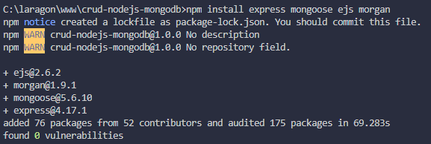

npm install nodemon -D

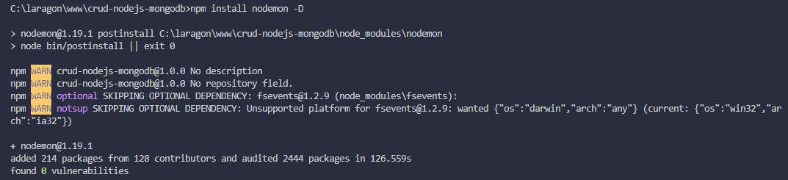

package.json

{
"name": "crud-nodejs-mongodb",
"version": "1.0.0",
"description": "",
"main": "index.js",
"scripts": {
"test": "echo \"Error: no test specified\" && exit 1"
},
"keywords": [],
"author": "",
"license": "ISC",
"dependencies": {
"ejs": "^2.6.2",
"express": "^4.17.1",
"mongoose": "^5.6.10",
"morgan": "^1.9.1"
},
"devDependencies": {
"nodemon": "^1.19.1"
}
}

Configurando o servidor

app.js

const express = require('express');
const app = express();

// settings
app.set('port', process.env.PORT || 3000);

app.listen(app.get('port'), () => {
console.log(`server on port ${app.get('port')}`);
});

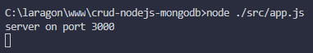

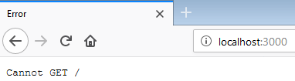

O erro especificado é porque ainda não foi definida nenhuma rota para a página principal.

package.json

{
"name": "crud-nodejs-mongodb",
"version": "1.0.0",
"description": "",
"main": "index.js",
"scripts": {
"start": "node src/app.js",
"dev": "nodemon src/app.js"
},
"keywords": [],
"author": "",
"license": "ISC",
"dependencies": {
"ejs": "^2.6.2",
"express": "^4.17.1",
"mongoose": "^5.6.10",
"morgan": "^1.9.1"
},
"devDependencies": {
"nodemon": "^1.19.1"
}
}

Em produção (production), no servidor de hospedagem será executado:

npm start

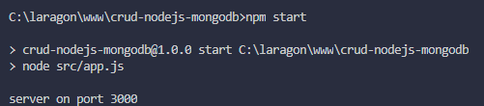

Em desenvolvimento (devlopment), no servidor local será executado:

npm run dev

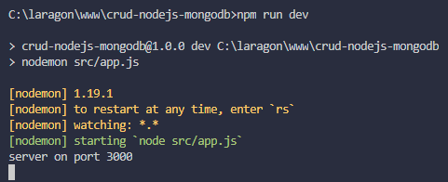

Configurando views

app.js

const path = require('path');
const express = require('express');
const app = express();

/* settings */

// configurando a porta do servidor
app.set('port', process.env.PORT || 3000);

// configurando o diretório de views
app.set('views', path.join(__dirname, 'views'));

// definindo o motor de templates
app.set('view engine', 'ejs');

/* starting the server */
app.listen(app.get('port'), () => {
console.log(`server on port ${app.get('port')}`);
});

Configurando Middlewares

app.js

const path = require('path');
const express = require('express');
const morgan = require('morgan');

const app = express();

/* settings */

// configurando a porta do servidor
app.set('port', process.env.PORT || 3000);

// configurando o diretório de views
app.set('views', path.join(__dirname, 'views'));

// definindo o motor de templates
app.set('view engine', 'ejs');

/* middlewares */
app.use(morgan('dev'));

/* starting the server */
app.listen(app.get('port'), () => {
console.log(`server on port ${app.get('port')}`);
});

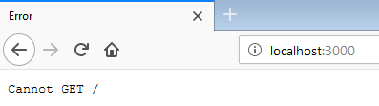

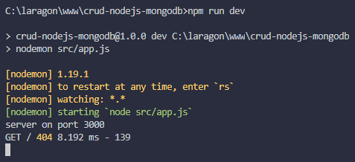

Conectando com o banco de dados

Rodando o servidor do Mongo

- Criar a pasta c:\mongodb e copiar os arquivos do Mongo para dentro dela.

- Dentro da pasta mongodb criar a subpasta data e dentro dela criar a subpasta db.

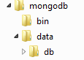

- Inserir o caminho da pasta bin do MongoDB no path do Windows.

C:\mongodb\bin

Importante: É dentro desta pasta mongodb/data/db que serão salvos os arquivos criados pelo Mongo.

Abrindo o servidor do MongoDB no Windows 7 - 32 bits

Sempre que for trabalhar com o MongoDB é necessário abrir o seu servidor. Para isso, entre no seu terminal com o seguinte comando:

mongod --storageEngine=mmapv1 --dbpath c:\mongodb\data\db --port 27017

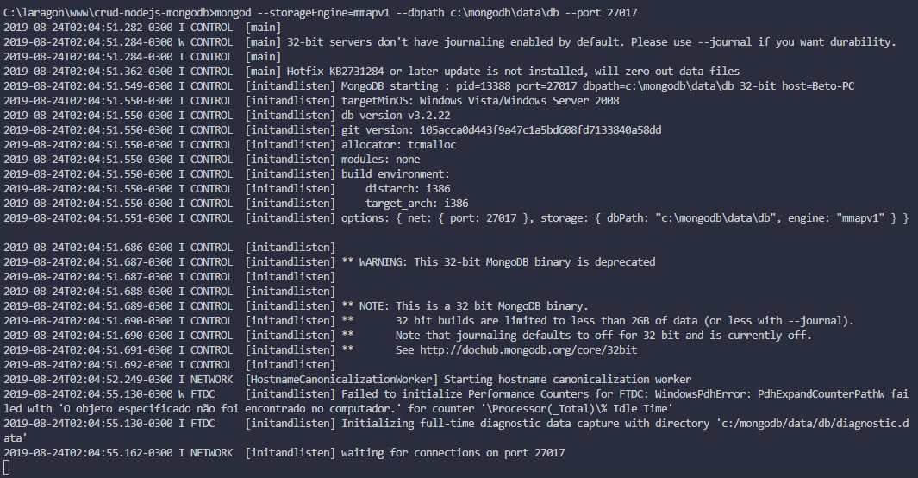

Configurando as rotas e a conexão com o BD

app.js

const path = require('path');
const express = require('express');
const morgan = require('morgan');
const mongoose = require('mongoose');

const app = express();

/* connection to db */

mongoose.connect('mongodb://localhost/crud-mongo')
.then(db => console.log('db connected'))
.catch(err => console.log(err));

/* Importing routes */

const indexRoutes = require('./routes/index');

/* settings */

// configurando a porta do servidor
app.set('port', process.env.PORT || 3000);

// configurando o diretório de views
app.set('views', path.join(__dirname, 'views'));

// definindo o motor de templates
app.set('view engine', 'ejs');

/* middlewares */

app.use(morgan('dev'));

// para entender os dados que vem de um formulário
app.use(express.urlencoded({extended: false}));

/* routes */
app.use('/', indexRoutes);

/* starting the server */

app.listen(app.get('port'), () => {
console.log(`server on port ${app.get('port')}`);
});

Não é necessário criar a BD porque se ela não existe será criada automaticamente com o nome dado. Nesse caso, o nome do database criado será crud-mongo.

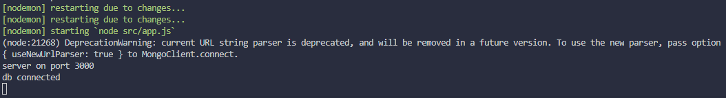

Uma conexão agora está aberta:

Configurando Models

src/models/task.js

const mongoose = require('mongoose');
const Schema = mongoose.Schema;

const TaskSchema = Schema({
title: String,
description: String,
status: {
type: Boolean,
default: false
}
});

module.exports = mongoose.model('tasks', TaskSchema);

Configurando a rota principal

src/routes/index.js

const express = require('express');
const router = express.Router();

router.get('/', (req, res) => {
res.send('Hello World!');
});

module.exports = router;

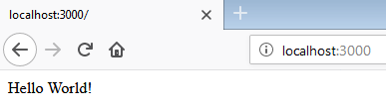

src/routes/index.js

const express = require('express');
const router = express.Router();

router.get('/', (req, res) => {
res.render('index');
});

module.exports = router;

src/views/index.ejs

<!DOCTYPE html>
<html>
<head>
<meta charset="utf-8">
<title>CRUD Nodejs y MongoDb</title>
<!-- BOOTSTRAP CDN -->
<link rel="stylesheet" href="https://stackpath.bootstrapcdn.com/bootstrap/4.1.0/css/bootstrap.min.css" integrity="sha384-9gVQ4dYFwwWSjIDZnLEWnxCjeSWFphJiwGPXr1jddIhOegiu1FwO5qRGvFXOdJZ4" crossorigin="anonymous">
</head>
<body>

<nav class="navbar navbar-dark bg-dark mb-4">
<a class="navbar-brand" href="#">CRUD Nodejs Y Mongodb</a>
</nav>

<div class="container">
<h1>Hello World</h1>
</div>

</body>
</html>

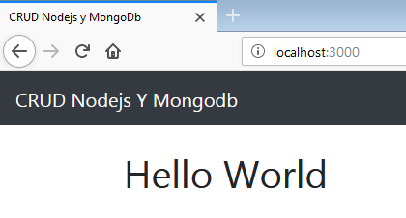

src/views/index.ejs

<% include partials/_header %>

<div class="container">
<h1>Hello World</h1>
</div>

<% include partials/_footer %>

src/views/partials/_header.js

<!DOCTYPE html>
<html>
<head>
<meta charset="utf-8">
<title>CRUD Nodejs y MongoDb</title>
<!-- BOOTSTRAP CDN -->
<link rel="stylesheet" href="https://stackpath.bootstrapcdn.com/bootstrap/4.1.0/css/bootstrap.min.css" integrity="sha384-9gVQ4dYFwwWSjIDZnLEWnxCjeSWFphJiwGPXr1jddIhOegiu1FwO5qRGvFXOdJZ4" crossorigin="anonymous">
</head>
<body>

<nav class="navbar navbar-dark bg-dark mb-4">
<a class="navbar-brand" href="#">CRUD Nodejs Y Mongodb</a>
</nav>

src/views/partials/_footer.js

</body>
</html>

src/views/index.ejs

<% include partials/_header %>

<div class="container">
<div class="row">
<!--FORM-->
<div class="col-md-5">
<div class="card">
<div class="card-body">
<form action="/add" method="post">
<div class="form-group">
<input class="form-control" type="text" name="title" placeholder="Title">
</div>
<div class="form-group">
<textarea class="form-control" name="description" cols="80"
placeholder="Add a Description"
></textarea>
</div>
<button class="btn btn-primary btn-block" type="submit">
Add
</button>
</form>
</div>
</div>
</div>
</div>

<% include partials/_footer %>

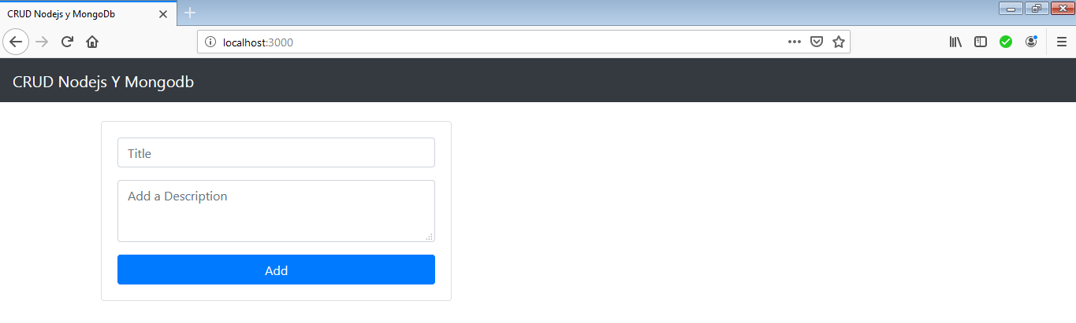

src/views/index.ejs

<% include partials/_header %>

<div class="container">
<div class="row">
<!--FORM-->
<div class="col-md-5">
<div class="card">
<div class="card-body">
<form action="/add" method="post">
<div class="form-group">
<input class="form-control" type="text" name="title" placeholder="Title">
</div>
<div class="form-group">
<textarea class="form-control" name="description" cols="80"
placeholder="Add a Description"
></textarea>
</div>
<button class="btn btn-primary btn-block" type="submit">
Add
</button>
</form>
</div>
</div>
</div>

<!-- LIST -->
<div class="col-md-7">
<table class="table table-bordered table-hover">
<thead>
<tr>
<th>N°</th>
<th>Title</th>
<th>Description</th>
<th>Operations</th>
</tr>
</thead>
<tbody>
</tbody>
</table>
</div>
</div>

</div>

<% include partials/_footer %>

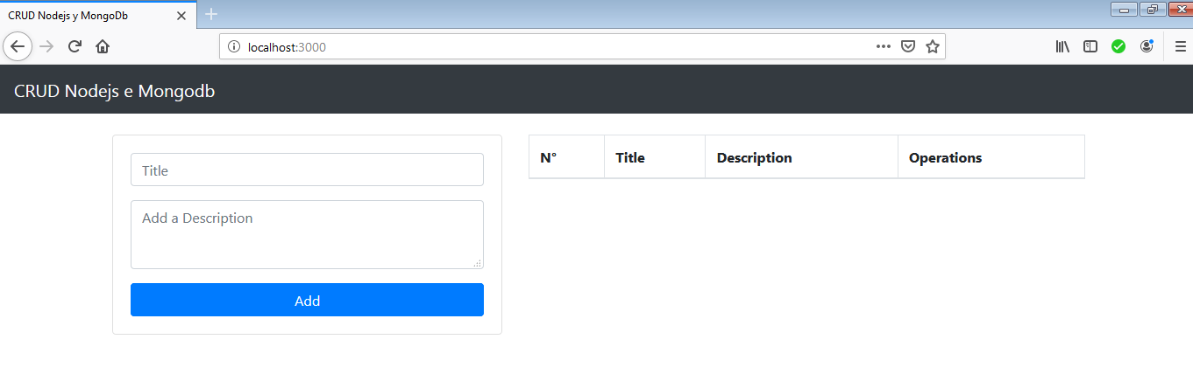

Rota para adicionar uma tarefa

src/routes/index.js

const express = require('express');
const router = express.Router();

const Task = require('../models/task');

router.get('/', (req, res) => {
res.render('index');
});

router.post('/add', (req, res, next) => {
console.log(req.body);
res.send('Received');
});

module.exports = router;

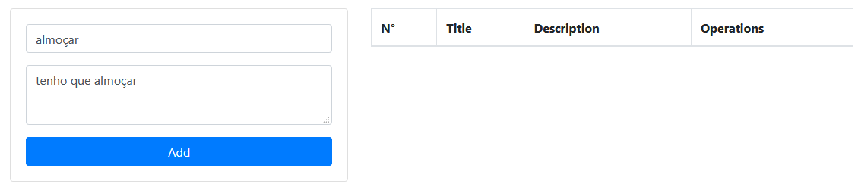

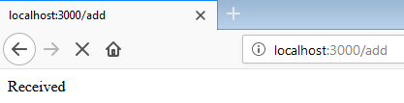

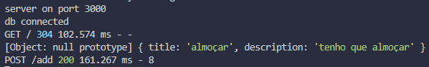

src/routes/index.js

const express = require('express');
const router = express.Router();

const Task = require('../models/task');

router.get('/', (req, res) => {
res.render('index');
});

router.post('/add', (req, res, next) => {
console.log(new Task(req.body));
res.send('Received');
});

module.exports = router;

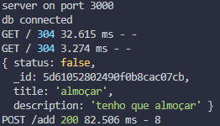

Criando e listando tarefas

src/routes/index.js

const express = require('express');
const router = express.Router();

const Task = require('../models/task');

router.get('/', async (req, res) => {
const tasks = await Task.find();
res.render('index', {
tasks
});
});

router.post('/add', async (req, res, next) => {
const task = new Task(req.body);
await task.save();
res.redirect('/');
});

module.exports = router;

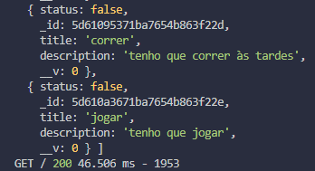

src/views/index.ejs

<% include partials/_header %>

<pre><%= tasks %></pre>

<div class="container">
<div class="row">
<!--FORM-->
<div class="col-md-5">
<div class="card">
<div class="card-body">
<form action="/add" method="post">
<div class="form-group">
<input class="form-control" type="text" name="title" placeholder="Title">
</div>
<div class="form-group">
<textarea class="form-control" name="description" cols="80"
placeholder="Add a Description"
></textarea>
</div>
<button class="btn btn-primary btn-block" type="submit">
Add
</button>
</form>
</div>
</div>
</div>

<!-- LIST -->
<div class="col-md-7">
<table class="table table-bordered table-hover">
<thead>
<tr>
<th>N°</th>
<th>Title</th>
<th>Description</th>
<th>Operations</th>
</tr>
</thead>
<tbody>
</tbody>
</table>

</div>
</div>

</div>

<% include partials/_footer %>

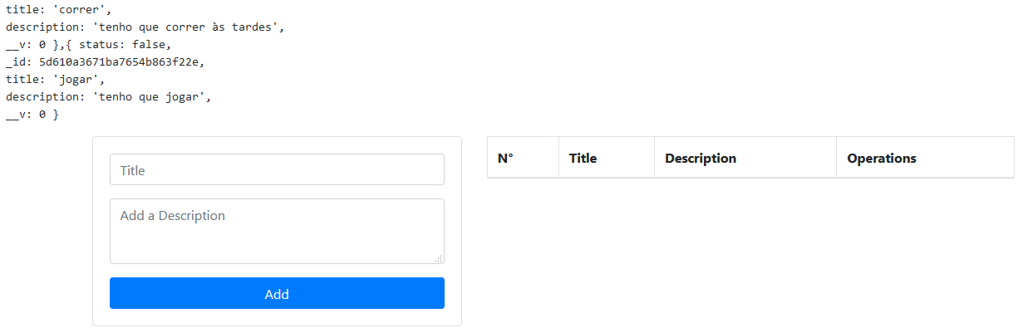

src/views/index.ejs

<% include partials/_header %>

<div class="container">
<div class="row">
<!--FORM-->
<div class="col-md-5">
<div class="card">
<div class="card-body">
<form action="/add" method="post">
<div class="form-group">
<input class="form-control" type="text" name="title" placeholder="Title">
</div>
<div class="form-group">
<textarea class="form-control" name="description" cols="80"
placeholder="Add a Description"
></textarea>
</div>
<button class="btn btn-primary btn-block" type="submit">
Add
</button>
</form>
</div>
</div>
</div>

<!-- LIST -->
<div class="col-md-7">
<table class="table table-bordered table-hover">
<thead>
<tr>
<th>N°</th>
<th>Title</th>
<th>Description</th>
<th>Operations</th>
</tr>
</thead>
<tbody>
<% for(var i=0; i < tasks.length; i++) { %>
<tr>
<td><%= i + 1%></td>
<td><strong><%= tasks[i].title %></strong></td>
<td><%= tasks[i].description %></td>
<td>
<a
class="<%= tasks[i].status ? 'btn btn-success' : 'btn btn-dark'%>"
href="/turn/<%= tasks[i]._id %>">Done</a>
<a href="/delete/<%= tasks[i]._id %>"
class="btn btn-danger">
Delete
</a>
<a href="/edit/<%= tasks[i]._id %>" class="btn btn-info">
Edit
</a>
</td>
</tr>
<% } %>
</tbody>
</table>

</div>
</div>

</div>

<% include partials/_footer %>

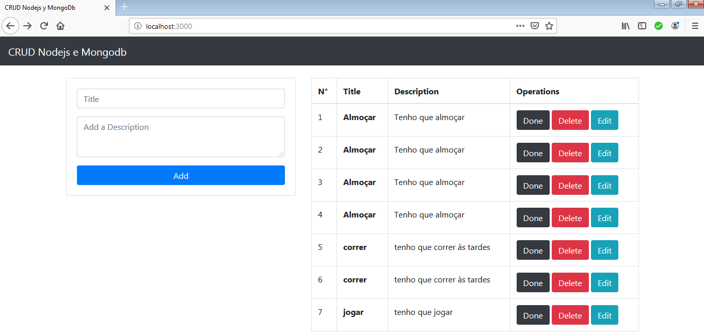

Deletando tarefas

src/routes/index.js

const express = require('express');
const router = express.Router();

const Task = require('../models/task');

router.get('/', async (req, res) => {
const tasks = await Task.find();
console.log(tasks);
res.render('index', {
tasks
});
});

router.post('/add', async (req, res, next) => {
const task = new Task(req.body);
await task.save();
res.redirect('/');
});

router.get('/delete/:id', async (req, res, next) => {
let { id } = req.params;
await Task.remove({_id: id});
res.redirect('/');
});

module.exports = router;

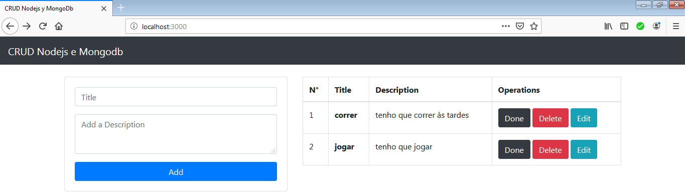

Marcando tarefas como realizadas ou não realizadas

src/routes/index.js

const express = require('express');
const router = express.Router();

const Task = require('../models/task');

router.get('/', async (req, res) => {
const tasks = await Task.find();
console.log(tasks);
res.render('index', {
tasks
});
});

router.post('/add', async (req, res, next) => {
const task = new Task(req.body);
await task.save();
res.redirect('/');
});

router.get('/turn/:id', async (req, res, next) => {
let { id } = req.params;
const task = await Task.findById(id);
task.status = !task.status;
await task.save();
res.redirect('/');
});

router.get('/delete/:id', async (req, res, next) => {
let { id } = req.params;
await Task.remove({_id: id});
res.redirect('/');
});

module.exports = router;

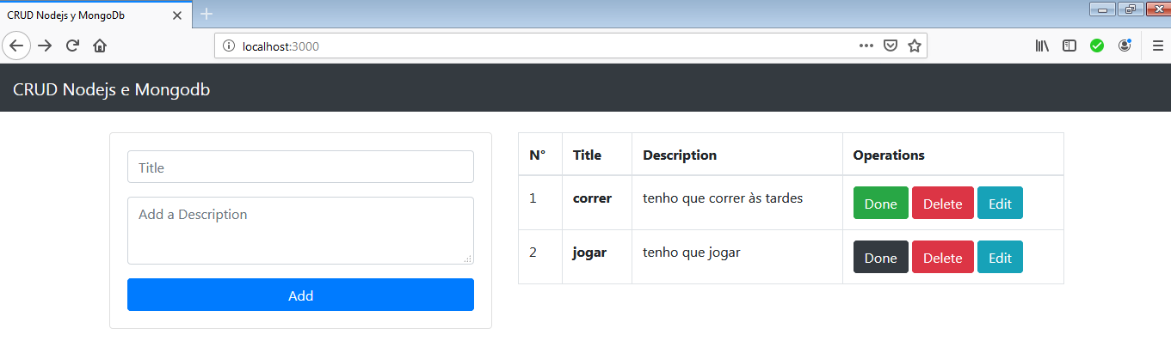

Editando uma tarefa

src/routes/index.js

const express = require('express');
const router = express.Router();

const Task = require('../models/task');

router.get('/', async (req, res) => {
const tasks = await Task.find();
console.log(tasks);
res.render('index', {
tasks
});
});

router.post('/add', async (req, res, next) => {
const task = new Task(req.body);
await task.save();
res.redirect('/');
});

router.get('/turn/:id', async (req, res, next) => {
let { id } = req.params;
const task = await Task.findById(id);
task.status = !task.status;
await task.save();
res.redirect('/');
});

router.get('/edit/:id', async (req, res, next) => {
const task = await Task.findById(req.params.id);
console.log(task)
res.render('edit', { task });
});

router.post('/edit/:id', async (req, res, next) => {
const { id } = req.params;
await Task.update({_id: id}, req.body);
res.redirect('/');
});

router.get('/delete/:id', async (req, res, next) => {
let { id } = req.params;
await Task.remove({_id: id});
res.redirect('/');
});

module.exports = router;

src/views/edit.ejs

<% include partials/_header %>

<div class="container">
<div class="row">
<!--FORM-->
<div class="col-md-5 offset-md-3">
<div class="card">
<div class="card-body">
<form action="/edit/<%= task._id %>" method="post">
<div class="form-group">
<input class="form-control" type="text" name="title" placeholder="Title" value="<%= task.title %>">
</div>
<div class="form-group">
<textarea class="form-control" name="description" cols="80"
placeholder="Add a Description"
><%= task.description %></textarea>
</div>
<button class="btn btn-primary" type="submit">
Update
</button>
</form>
</div>
</div>
</div>
</div>
</div>

<% include partials/_footer%>

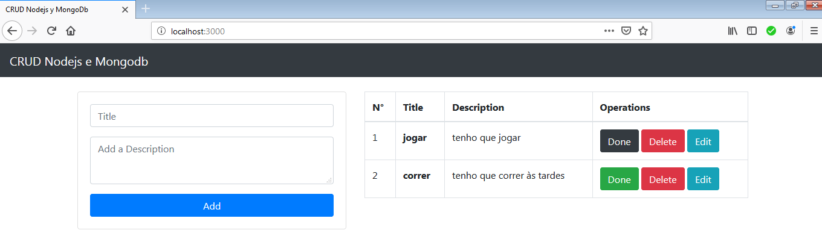

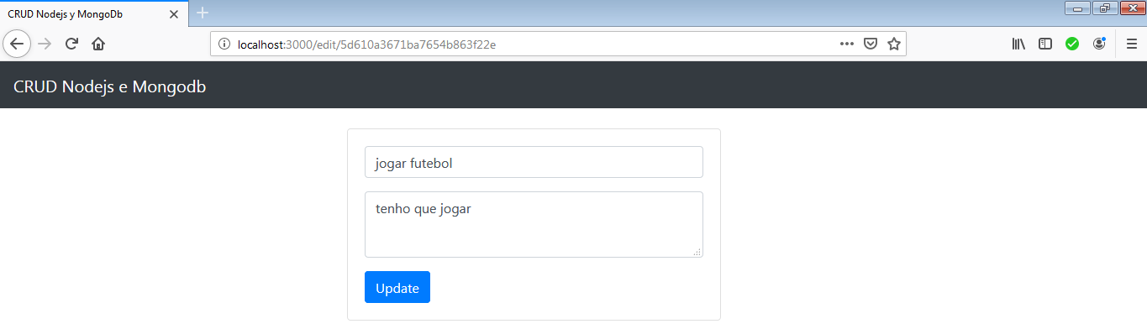

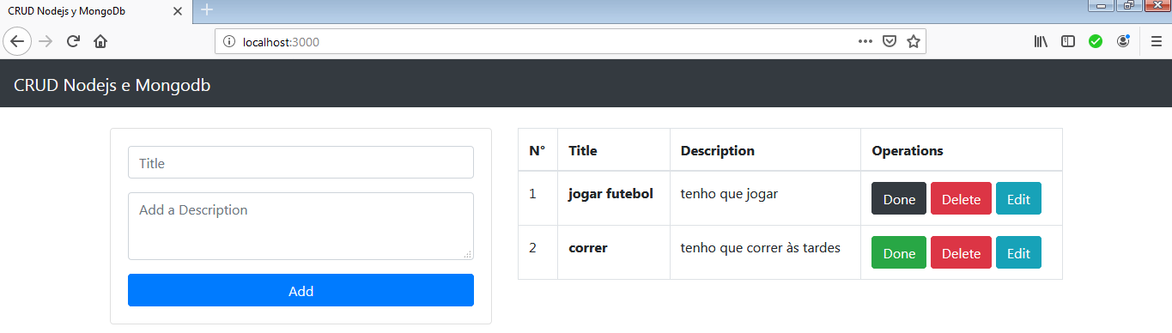

String de conexão

mongodb+srv://betopinheiro1005:<password>@cluster-nodejs-mongodb-ulvuw.mongodb.net/crud-mongo?retryWrites=true&w=majority

